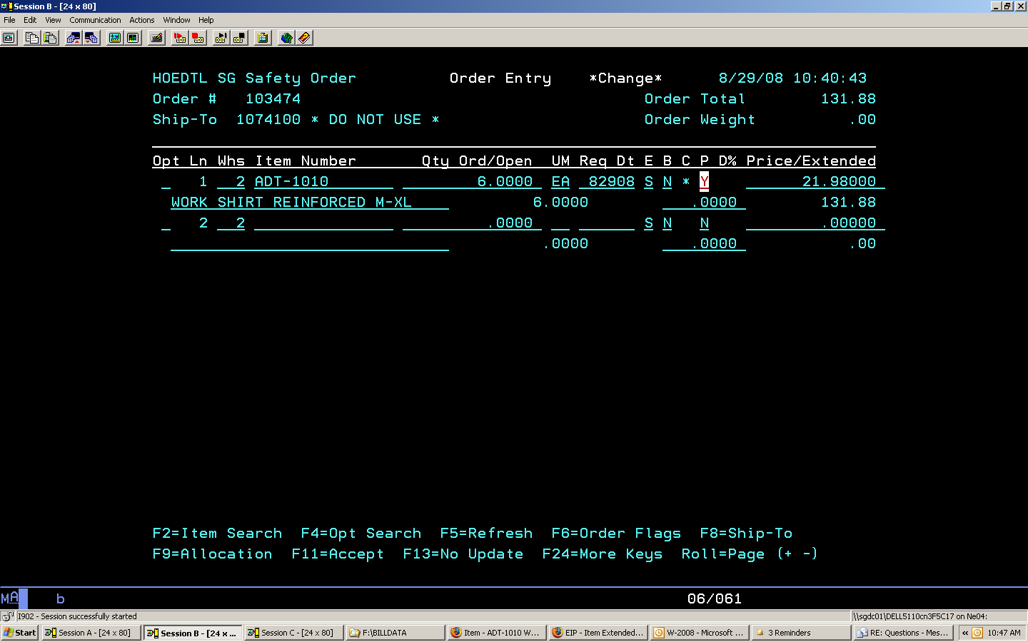

Figure #1. On line item. Note field cursor is in. It defaults to N. Must be changed to Y to generate PO.

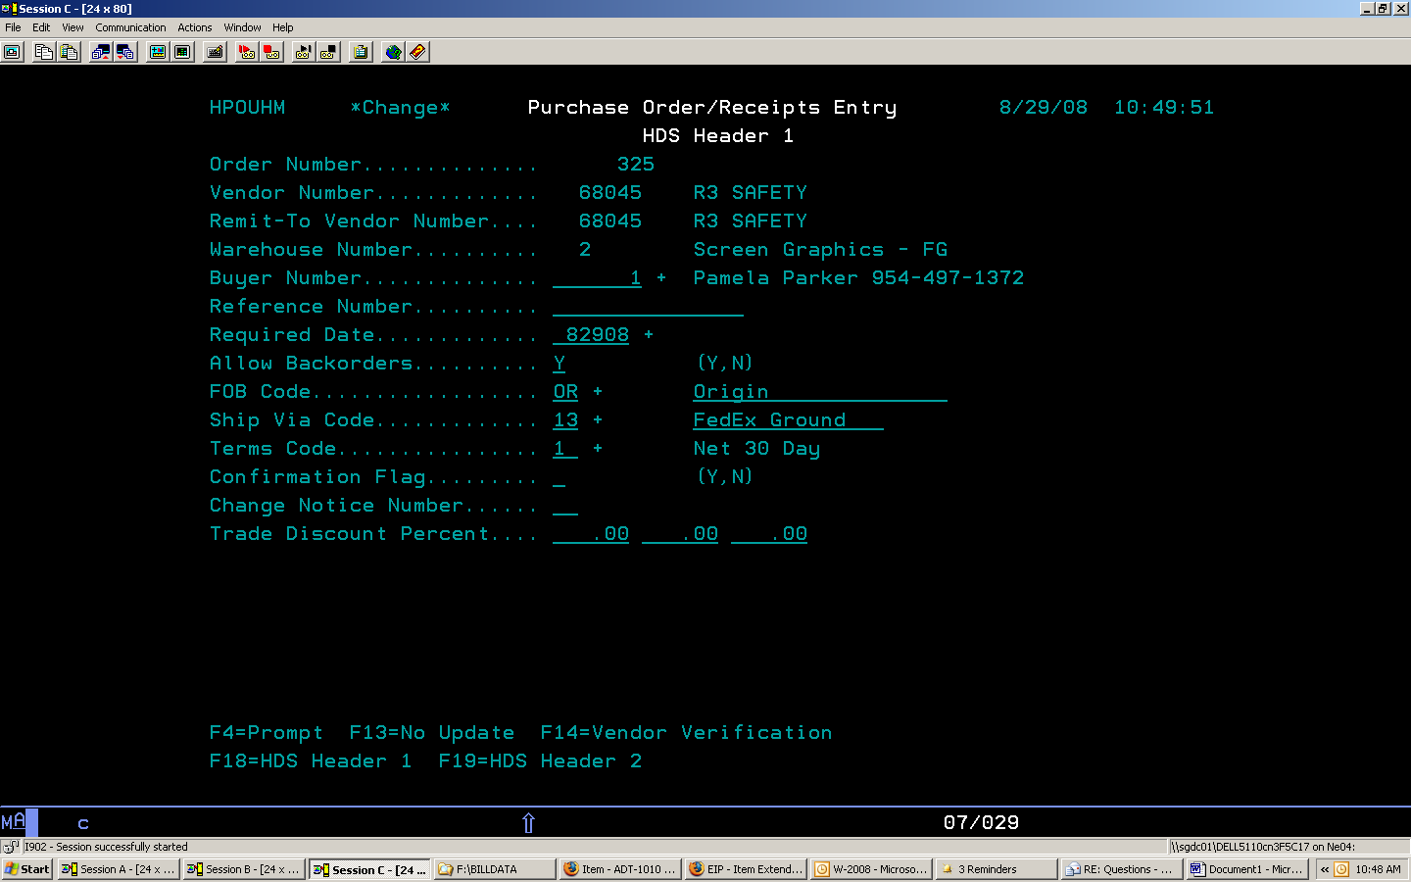
Figure #2. Note Ship Via method. This is reflective of shipping method entered on CO.

